Title: The Importance of Arts
Jackie Bowden

The drama department in my high school could have seen better days. Costumes were over 20 years old and sometimes damaged. Drama classes didn’t involve current scripts and textbooks. Instead, papers were copied and printed numerous and given to students. The backstage gathered in dust, and items piled high due to the lack of space for a proper backstage. The chairs in the auditorium were falling apart and some were missing the seats.

Yet, despite much needed attention, the school district did not offer much funding to the art departments.

However, my self-confidence and happiness soared every time I was on stage, whether in performance or rehearsal. Those emotions are feelings that every child and teen should experience.

Art, drama and music classes were offered, but there was no requirement to take them as part of my high school’s curriculum. Luckily for me, I was exposed to dance and theatre at an early age so I knew they were activities that I loved and knew how much they improved my development.

The National Center for Educational Statistics breaks down the number of states that require districts or schools to offer arts instruction at the each education level:
- Elementary School: 45
- Middle School: 41
- High School: 27

Now, while these numbers are good for the elementary and middle school bracket, the high school bracket is poor. Also, these states require the offer of arts classes, which doesn’t mean that all students are taking these courses since they are not required classes.

Massachusetts is one of the states that don’t even require schools to offer arts classes, lessening even more of a chance of students being exposed to the art. It is up to each school district to decide if art classes will be offered.

A decline in arts based learning is due to the No Child Left Behind Act (NCLB), which was passed in 2001. While the goal of NCLB is to “ensure that all children have a fair, equal, and significant opportunity to obtain a high-quality education”, it is only through state wide tests in math and language arts that each school’s success is determined on. Schools and their districts are held accountable for low tests scores in math and English, so those subject areas are the main focus of many public schools around the country.

However, in recent years, more people have taken notice that the arts do not take away from learning, but improve it. One report lead by President Barack Obama and first lady Michelle Obama, Reinvesting in Arts Education: Winning America’s Future Through Creative Schools, pushes schools to add arts programming.

The report acknowledges that not only will the arts improve test scores (a necessary evil in today’s education), but will help students develop self-confidence, creative and critical thinking skills, heighten educational aspirations and improve social skills.

In addition to adding more art classes, there are many programs groups that go to schools to expose children to different forms of art. For example, the Boston Ballet offers an initiative called CityDance.

CityDance is a program where teachers from Boston Ballet School go to Boston Public Schools and do a one hour demonstration and class for third graders. From there, interested students are invited to a 10 week program at Boston Ballet School and then are offered scholarships to continue their dance training.

Although this program isn’t an everyday class, it does expose children to an art form. Other programs across the country are helping to push arts into schools. Seattle, Washington’s Office of Arts and Culture has teamed up with the city’s public schools to offer more arts programs during the school year.

One initiative, the Central Arts Pathway, is working on having “2 hours of music and visual arts each week for elementary learners to integrated and culturally relevant experiences, and career development opportunities for middle and high schoolers.” (http://artbeat.seattle.gov)

This initiative’s goal is to have a fully integrated arts program within Seattle Public Schools by 2020. Although it is going to take quite some time for this to be fully integrated in the school system, it is good that Seattle is making the effort to improve their art programs.

Arts are slowly gaining more momentum in public schooling. The mindset is still focused on improving test skills, but the arts have so much more to offer. Through my experience I know that the arts can improve self-esteem and create bonds between students. To bring the arts back into curriculums will help students realize that they can succeed in school and beyond.

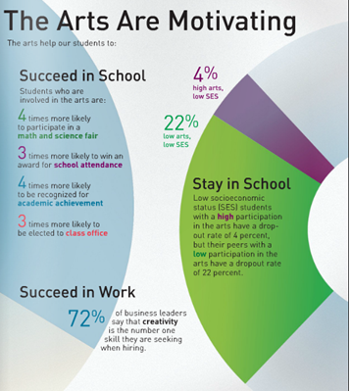

http://thethunderproject.org/wp-content/uploads/2013/04/ariel-graph-2.png

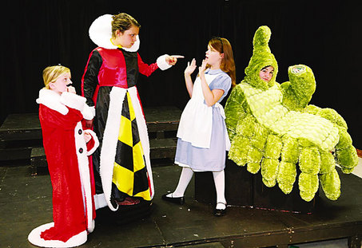
http://blog.al.com/go/2008/06/large_alice-in-wonderland.jpg

Sources
http://www.doe.mass.edu/frameworks/arts/1099.pdf

http://musicstandards.org/states/massachusetts/

http://www.americansforthearts.org/by-program/reports-and-data/legislation-policy/legislative-issue-center/arts-education-policy-and-funding

http://www.doe.mass.edu/grants/2015/189/

http://blog.artsusa.org/2014/09/18/connecting-creative-youth-development-and-in-school-arts-education/?utm_source=feedburner&utm_medium=feed&utm_campaign=Feed%3A+afta%2Fblog+%28Americans+for+the+Arts+%7C+Blog%29

http://www.giarts.org/article/public-funding-arts-2012-update

http://www.lynnschools.org/documents/superintendent/budgets/LPS_FY14%20Approved%20School%20Budget.pdf

http://www.americansforthearts.org/by-program/networks-and-councils/arts-education-network/tools-resources

http://www.americansforthearts.org/sites/default/files/pdf/2013/by_program/networks_and_councils/arts_education_network/A-Shared-Endeavor.pdf

http://www.aep-arts.org/wp-content/uploads/2012/03/NAEP-Summary_of_Results.pdf

http://nces.ed.gov/programs/statereform/tab5_13.asp

http://www.city-data.com/school/Lynn-Massachusetts.html

http://pcah.gov/sites/default/files/Turnaround%20Arts%20Interim%20Evaluation_November%202013_0.pdf

http://www.washingtonpost.com/blogs/answer-sheet/post/report-why-we-need-arts-education-not-only-to-improve-test-scores/2011/05/19/AFRuXT7G_blog.html

http://www.edutopia.org/arts-music-curriculum-child-development

http://www.seattle.gov/arts/education/default.asp

http://www.bostonballet.org/community/city-dance.html

http://artbeat.seattle.gov/2013/09/25/creative-advantage-arts-education-update/

